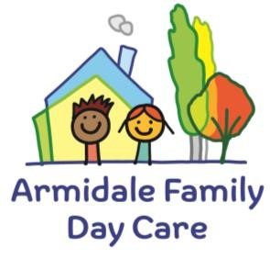
Armidale & District Family Day Care Ltd 95 Faulkner Street
Armidale NSW 2350
Ph: 02 6772 5300
Email: admin@afdc.org.au Authorisation to Administer Medication
(To be completed by the child’s parent or the person nominated to give authorisation on the child’s enrolment form) Please do not leave medication in your child’s bag.
I give permission for (Educator)………………………………………………………………….…to administer medication to (Childs Name):...........................................
Date of birth .................................................. as tabled below.
I give permission for my school aged child ................................ to self -administer medication for their medical condition under the supervision of (Educator)
 |  | To be completed by the parent/guardian |  |  |  |  |  |  |  | To be completed by the Educator when administered
Name of medication | Reason for medication |  | Last administered |  | To be administered  (or  circumstances to be administered) |  | Dosage  to  be  administered | Method of  administration | Signature of parent/Guardian | Medication administered |  | Dosage  Administration | Method of  administrati on | Name  of  educator  administering | Signature  of  educator  administering
 |  |  | Time | Date | Time | Date |  |  |  | Time | Date
……………………………………as tabled below.
Reviewed August 2023

