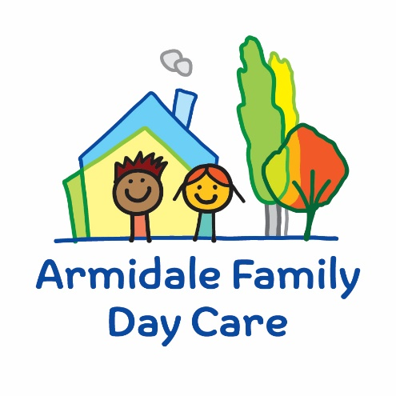

Armidale & District Family Day Care Ltd
95 Faulkner Street (PO Box 951)
Armidale NSW 2350
Ph: 02 6772 5300
Email: admin@afdc.org.au

Armidale & District Family Day Care Excursion Risk assessment

Approved providers, nominated supervisors and family day care educators must ensure a risk assessment is carried out before children are taken outside the service premises on an excursion. Prior authorisation must also be obtained from parents or other authorised nominees.

Regulation 100 Risk Assessment must be conducted, A family day care educator must carry out a risk assessment in accordance with regulation 101 before an authorisation referred to in regulation 102(4) is sought for an excursion. Penalty $2000

Regulation 101 of the Education and Care Services National Regulations includes the minimum risk assessment considerations for excursions, including specific considerations when an excursion involves transporting children.

Regulation 102 Authorisations for Excursions. Penalty $1000

Note: A risk assessment is only required to be completed at least once for a 12-month period if the excursion is a ‘regular outing*’.

*Regular outing: means a walk, drive, or trip to and from a destination that the service visits regularly as part of its educational program, and where the circumstances relevant to the risk assessment are substantially the same on each outing.

Service Name
Excursion details
Date (s) of excursion.
If it is a regular outing include a description of when children are to be taken on regular outings.
If it is a non-routine outing include the date this outing will be taken.
Proposed Activities.
List all activities that will take place during the excursion.
Pick up location and destination(s).
List each location travelled to and from as part of the excursion.
E.g., The Museum, park for lunch and service.
Estimated departure and arrival times and duration of the excursion.

E.g. from the service to each destination and returning to the service.
Proposed route.
You can include an image of the route sourced online.
Means of transport
E.g., public bus, private bus, coach, private car, taxi
Requirements for seatbelts or safety restraints in your state or territory have been met. | Yes / No Comment:

Names & numbers of educators / responsible adults, appropriate to provide supervision, and whether any adults with specialised skills are required.
E.g., for children’s individual
needs.
The number of children involved in the excursion.
Any water hazards during the excursion, including any risks associated with water-based activities?  If yes, detail in the risk assessment table below. | Yes / No Comment:
Educator to child ratio, including whether this excursion warrants a higher ratio.
Provide details in the risk assessment table below.
Describe the process for entering and exiting the service premises and the pick-up location or destinations (as required); (include how each child is accounted for):

Describe the procedures for embarking and disembarking the vehicle (include how each child is accounted for in embarking and disembarking):
Excursion checklist – items to be readily available during the excursion (please tick)
□ First aid kit | □ List of adults involved in the excursion
□ List of children involved in the excursion | □ Contact information for each adult
□ Contact information for each child | □ Mobile phone / other means of communicating with the service & emergency services
□ Medication, health plans and risk assessments for individual children | □ Other items, please list

Use the table below to identify and assess risks to the safety, health or wellbeing of children attending the excursion, and specify how these risks will be managed and minimised [regulation 101(1)]. This must include any risks associated with water-based activities.

Risk assessment
Activity | Hazard identified | Risk assessment (use matrix) | Elimination/control measures | Who | When
(Press tab to add more rows)

Risk Matrix
Likelihood | Consequence
 |  |  | Insignificant | Minor | Moderate | Major | Catastrophic
 |  | Almost certain | Moderate | High | High | Extreme | Extreme
 |  | Likely | Moderate | Moderate | High | Extreme | Extreme
 |  | Possible | Low | Moderate | High | High | Extreme
 |  | Unlikely | Low | Low | Moderate | High | High
 |  | Rare | Low | Low | Low | Moderate | High

Plan and Review
Plan prepared by: | Full name: Signature: Role/Position: | Date:
Communicated to AFDC Coordination Unit: | Yes / No Lois/Beth/Gemma/Sharon/Patricia  Comment if needed:
Vehicle safety information reviewed and attached: | Yes / No  Comment if needed:
Risk assessment to be evaluated and reviewed on:  A risk assessment must be undertaken prior to an excursion being undertaken (and before seeking authorisation for that excursion to be undertaken - see regulation 102). If the excursion is a 'regular outing'*, a risk assessment must be undertaken at least annually. | Date:

