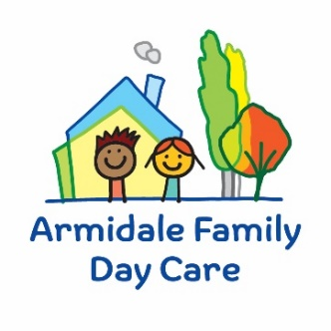

Parent/Guardian Request for Educator Additional Approval
Regulation 124 Number of children who can be educated and cared for—family day care educator,
- A family day care educator must not educate and care for more than 7 children at a family day care residence or approved family day care venue at any one time….
(5) Despite sub regulations (1) to (4), the approved provider of a family day care service may approve, in writing, a family day care educator to educate and care for more than 7 children, or more than 4 children who are preschool age or under, at any one time, in exceptional circumstances. (6) For the purposes of sub regulation (5), exceptional circumstances exist if—
*(a) all the children being educated and cared for by the family day care educator are siblings in the same family; or
(b) a child to be educated and cared for is determined to be in need of protection under a child protection law and the family day care educator is determined to be the best person to educate and care for the child; or
(c) the family day care residence or approved family day care venue is in a rural or remote area and no alternative education and care service is available.
*Please note (a) is when the four children in care are from the same family and you are needing care for a fifth child.

Childs Full Name___________________________________________________Age_________
Date of Birth____________________________________________________________________
Date/s care is required_____________________________________
Preferred Educator name if no other Educator has spaces within ratio____________________________________________________________________________
Reason for Requesting Additional Approval ________________________________________________________________________________________________________________________________________________________________________________________________________________________________________________________________________________________________________________________________________________________________________________________

Parent/Guardian Name_____________________________________________
Signature _________________________________________________________
Date______________________________________________________________

