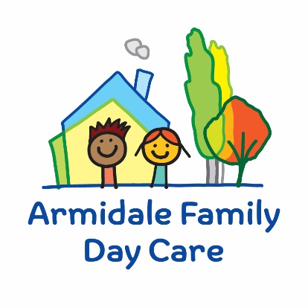

ARMIDALE FAMILY DAY CARE
CHILD SAFE CODE OF CONDUCT

Armidale Family Day Care (AFDC) strives to provide an open, welcoming, safe environment for all children enrolled in our service. We provide high quality education and care that is safe for all children. All management, staff, educators, and educators’ families are responsible for ensuring children are safe within our service.

We will:
- Take all reasonable steps to protect children from abuse.
- Have boundaries around appropriate interactions between adults and children.
- Help children to learn protective behaviours.
- Report and act on all complaints of abuse to the appropriate bodies.
- Provide an inclusive environment for all children in our service .
- Educate children about their rights.
- Support children to develop self-help skills and independence in relation to personal care and hygiene.
- Ensure that AFDC’s Visitor Policy is adhered to.
We will not:
- Put children at risk of abuse.
- Engage in inappropriate or unnecessary physical interaction with children.
- Have conversations of an inappropriate adult nature in the presence of children.
- Develop special relationships with individual children.
- Discriminate against any individual child based on culture, race or sexuality.
- Impose personal views to children, based culture, race or sexuality.
- Leave children alone with members of educator’s families or visitors to educator’s service.
- Prevent children from exercising their independence in relation to personal care.

I, ____________________________, acknowledge that I have read and understand this Child Safe Code of Conduct and commit to upholding it.
Signature: ____________________________
Date: ____________________________

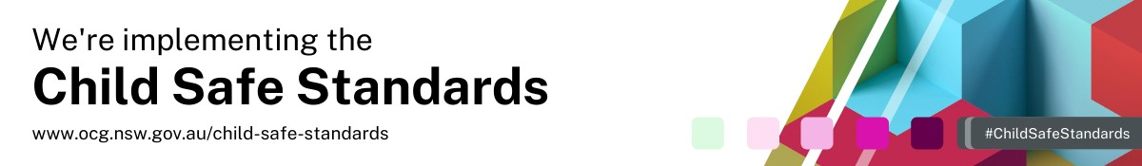
AFDC Child Safe Code of Conduct. October 2024

