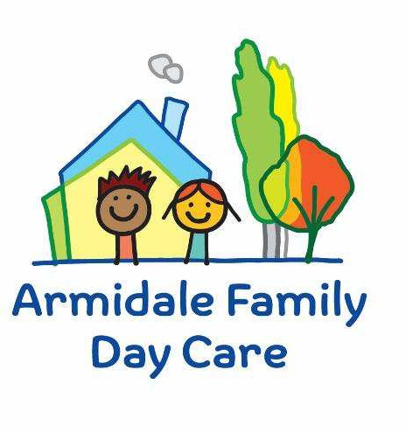

Armidale & District Family Day Care Ltd
95 Faulkner Street (PO Box 951)
Armidale NSW 2350
Ph: 02 6772 5300
Email: admin@afdc.org.au

Armidale Family Day Care Risk Minimisation and Communication Plan

This document will be completed in conjunction with the child’s family. Whenever there is a change in the child’s care environment or personal situation then this plan must be updated. This document is to be readily available in the child’s file.

Armidale Family Day Care must ensure that a Risk Minimisation and Communication Plan is developed for all children with a relevant medical condition or specific health care need, including but not limited to allergies, asthma, and diabetes.
This requirement is in accordance with the Education and Care Services National Regulations, specifically:

90 Medical conditions policy
(1) The medical conditions policy of the education and care service must set out practices in relation to the following—
(iii) requiring the development of a risk-minimisation plan in consultation with the parents of a child—
(A) to ensure that the risks relating to the child’s specific health care need, allergy or relevant medical condition are assessed and minimised; and
(B) if relevant, to ensure that practices and procedures in relation to the safe handling, preparation, consumption and service of food are developed and implemented; and
(C) if relevant, to ensure that practices and procedures to ensure that the parents are notified of any known allergens that pose a risk to a child and strategies for minimising the risk are developed and implemented; and
(D) to ensure that practices and procedures ensuring that all staff members and volunteers can identify the child, the child’s medical management plan and the location of the child’s medication are developed and implemented; and
(E) if relevant, to ensure that practices and procedures ensuring that the child does not attend the service without medication prescribed by the child’s medical practitioner in relation to the child’s specific health care need, allergy or relevant medical condition are developed and implemented; and
(iv) requiring the development of a communications plan to ensure that—
(A) relevant staff members and volunteers are informed about the medical conditions policy and the medical management plan and risk minimisation plan for the child; and
(B) a child’s parent can communicate any changes to the medical management plan and risk minimisation plan for the child, setting out how that communication can occur.

Service Name:

Place Child’s Photo Here
Childs Name: |  | DOB:
Parent/ Guardian Name: |  | Ph:
Dr/ Medical Practitioner Name:

Dr/ Medical Practitioner Address: |  | Dr/ Medical Practitioner Ph Number:
What is the medical condition/specific health care need affecting the child? (e.g. asthma, anaphylaxis, ASD, diabetes).
Please list any known triggers, signs and symptoms.
Please list any medication that has been prescribed by a medical practitioner for this medical condition/ specific health care need.
Medical Management/Action Plan Provided to Service:  ☐ Yes ☐No | Medical Management Plan/ Action Plan and Risk Minimisation and Communication Plan location: |  | Medication Location:

Is everyone at the service aware of the child at risk and how do you notify relief staff/ volunteers/ students?
What will you do to inform the child’s family of procedures and policies?
Do parents/families of this service need to be notified of any known issues/concerns that pose a risk to the child?  If yes, how will you notify parents/ families? | ☐ Yes ☐No

Risk Assessment and Minimisation Plan
Medical Condition/ Specific Health Care Need | Risks – what could go wrong? | Risk assessment (use matrix) | Minimisation/ Elimination/ Control Measures | Who | When
Likelihood:

Consequence:

Overall Risk:

Likelihood:

Consequence:

Overall Risk:

Likelihood:

Consequence:

Overall Risk:

Likelihood:

Consequence:

Overall Risk:

Likelihood:

Consequence:

Overall Risk:

Plan made in consolidation with:
Educator Name:  Signature:  Date: | Parent /Guardian Name:  Signature:  Date:
All ongoing communication in regard to this Risk Minimisation and Communication Plan is to be recorded below.

Ongoing Communication Notes

Date | Communication Notes

