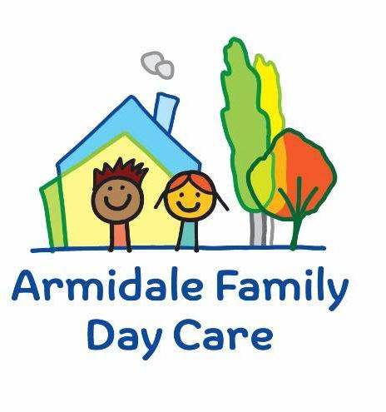
Armidale & District Family Day Care Ltd
95 Faulkner Street (PO Box 951)
Armidale NSW 2350
Ph: 02 6772 5300
Email: admin@afdc.org.au

Armidale & District Family Day Care Incursion Risk assessment

A risk assessment must be completed prior to an incursion being undertaken.
If an incursion is regular, a risk assessment must be reviewed annually.
Parent authorisations must be collected for each child involved in the incursion.
Parent authorisations must be reviewed annually for regular incursions.

Service Name: Armidale Family Day Care Family Day Care Educator:
Incursion Details
Date (s) of incursion.
If it is a regular incursion include a description of when children are to be involved in regular incursions
If it is a non-routine incursion include the date this outing will be taken.
Proposed Activities.
List all activities that will take place during the incursion.
Incursion Location.
List location incursion will take place.

Estimated departure and arrival times of incursion visitors and duration of the incursion.

Names & numbers of educators / responsible adults, appropriate to provide supervision, and whether any adults with specialised skills are required.
E.g., for children’s individual needs.
The number of children involved in the incursion.
Any water hazards during the incursion, including any risks associated with water-based activities?  If yes, detail in the risk assessment table below. | Yes / No Comment:
Educator to child ratio, including whether this incursion warrants a higher ratio.
Provide details in the risk assessment table below.
If Children will be leaving the registered area to go to an unregistered area please describe the process of how this will happen. ( include head check counts)
Incursion checklist – items to be readily available during the incursion
- First aid kit |  | - List of adults involved in the incursion
- List of children involved in the incursion |  | - Contact information for each adult
- Contact information for each child |  | - Mobile phone / other means of communicating with the service & emergency services
- Medication, health plans and risk assessments for individual children |  | - Other items, please list

Use the table below to identify and assess risks to the safety, health or wellbeing of children attending the incursion, and specify how these risks will be managed and minimised [regulation 101(1)]. This must include any risks associated with water-based activities.

Risk assessment
Activity | Hazard identified | Risk assessment (use matrix) | Elimination/control measures | Who | When
Incursion Visitors Arriving and Departing | Child goes missing | Likelihood: Unlikely  Consequence: Moderate  Risk: High | - Actively supervising children during arrivals and departures.  - Conducting roll calls of all children. | Educators | - During visitors’ arrivals and departures.  - Throughout the incursion.
Incursion | Severe weather/ storm | Likelihood: Possible  Consequence: Moderate  Risk: High | - Keep updated with weather forecast.  - If sever weather is forecast cancel/rearrange incursion.  - Close and lock all windows and doors.  - Close blinds/curtains.  - Follow shelter in place procedure, entering safe room away from windows where possible | Educator | Before excursion  During severe weather event.
Playing during Incursion | Intruder/Aggressor enters premises | Likelihood: Unlikely  Consequence: significant  Risk: High | - Keep doors and windows locked.  - Follow Breanna’s lockdown procedure and call 000.  - Be aware of any court orders surrounding families. | Educator | When intruder sighted on premises.
Playing in yard during incursion | Spiders, bees, snakes, vermin in yard. | Likelihood: Possible  Consequence: Major  Risk: High | - Complete outdoor safety checklists daily.  - Pest management (e.g) spray conducted regularly.  - Check equipment for spiders daily  - Have dangerous spiders information sheet for reference.  - All educators are first aid trained.  - Apply first aid and call 000.  - Go inside if snake or another dangerous animal is sighted.  - Contact Armidale Snake rescue and relocation on 0477 282 129 | Educator | Daily checklists  Pest management as required.  First aid training completed every 3 years.  CPR training completed annually.  When dangerous animal/ pest is sighted.
Playing during incursion | Fire (indoor) | Likelihood: Rare  Consequence: significant  Risk: High | - Rehearse fire evacuations every 3 months.  - Smoke alarms to be tested annually.  - Fire extinguisher and blanket tested and tagged every 6 months.  - Fire extinguisher and blanket in easily accessible area.  - In the event of fire, use fire safety equipment, evacuated area and call 000.  - Educators are first aid trained. | Educator | 3 monthly evacuation rehearsals  Annual testing of smoke alarms  6 monthly testing/tagging of fire extinguishers/ blankets.  First aid training completed every 3 years.  CPS training completed annually.
Playing during incursion | Fire (outdoor) | Likelihood: Rare  Consequence: Catastrophic  Risk: High | - Daily outdoor checklists.  - Maintain yard, removing debris.  - Rehearse fire evacuations every 3 months.  - Fire extinguisher and blanket tested and tagged every 6 months.  - Fire extinguisher and blanket in easily accessible area.  - In the event of fire, use fire safety equipment, evacuated area and call 000.  - Educators are first aid trained. | Educators | 3 monthly evacuation rehearsals  6 monthly testing/tagging of fire extinguishers/ blankets.  First aid training completed every 3 years.  CPR training completed annually.
Outdoor play | Sunburn | Likelihood: Possible  Consequence: Major  Risk: High | - Children and educator to wear hats and sunscreen, shirts covering shoulders and sunglasses if possible. | Educator | When outdoors
Outdoor play | Dehydration | Likelihood: Possible  Consequence: Major  Risk: High | - Children and educator to wear hats and sunscreen, shirts covering shoulder and sunglasses where possible.  - Take water bottles  - Ensure children take appropriate breaks to drink.  - Model frequent water drinking | Educator | During incursion
Playing on outdoor equipment | Injury due to falling off climbing frame/ swing set/ being hit by swing | Likelihood: Possible  Consequence: Moderate  Risk: High | - Active supervision.  - Conversations with children about safe use of play equipment.  - All educators are first aid trained.  - Call 000 in emergency.  - Climbing frame and swing set on soft area, such as grass.  - Swings low down | Educators a | During outdoor play
When playing | Conflict between children | Likelihood: Likely  Consequence: Moderate  Risk: High | - Active supervision  - Role modelling positive behaviour | Educators | Duration of incursion
(Press tab to add more rows)

Plan and Review
Plan prepared by: | Full name: Signature:  Role/Position: | Date:
Communicated to AFDC Coordination Unit: | Yes / No  Lois/Beth/Gemma/Sharon/Patricia Comment if needed:
Vehicle safety information reviewed and attached: | Yes / No  Comment if needed: NA
Risk assessment to be evaluated and reviewed on:  A risk assessment must be undertaken prior to an incursion being undertaken. If the incursion is 'regular'*, a risk assessment must be undertaken at least annually. | Date:

