Animal & Pet Management
Educators Name: | Educators address
Do you have pets : | No ☐ |  | Yes ☐ |  | Please complete the plan below for each pet
Type of Animal/Pet that reside at the FDC residence are | Breed: |  |  |  | Pet’s name: Age:
Date risk assessment made: | Date to review (every 12 months) :
Identified Risks |  | Yes |  | Management Strategy  (If required)
Pets are kept secure & inaccessible to children during business hours to avoid unsupervised access? |  | ☐
If pets are accessible, how are risks mitigated? |  | ☐
Pet Management is included in the Daily Hazard checklist? |  | ☐
FDC area is checked for droppings, food scraps, pet toys etc. before children have access to area? |  | ☐
Please explain your pet’s nature |  | ☐
What protective measures are in place to ensure the children’s health and safety around animals? |  | ☐
Opened pet food and water is inaccessible & stored away from children’s food? |  | ☐
Have you consulted children’s family regarding their child’s access to animals? |  | ☐
Have been checked for any related allergies and / or fear/phobias towards the animal/s or pets? |  | ☐
For health & hygiene purposes, my pets are checked regularly for lice, worms, fleas etc., washed regularly & vaccinated as required? |  | ☐
Internal FDC areas & vehicle to which my pets have access afterhours, will be cleaned prior to children arriving for care? |  | ☐
Fencing is to be maintained to prevent children from unsupervised access |  | ☐
Are there set procedures in place to guide care, safety and maintenance of the pets, animals, aquarium or enclosure? What are they |  | ☐
Fish tanks and aquariums are secure and don’t pose a risk to children? (i.e. water hazard, safety glass) |  | ☐
Families and visitors during FDC hours are informed of this Pet Management Plan? |  | ☐
I will consult with & inform the co-ordination unit and families of any changes to this Pet Management Plan |  | ☐

Hazards identified to specific pet:
Hazard identified | Likelihood and consequence  (use risk matrix) | First aid required | Risk mitigation strategies | Who | When
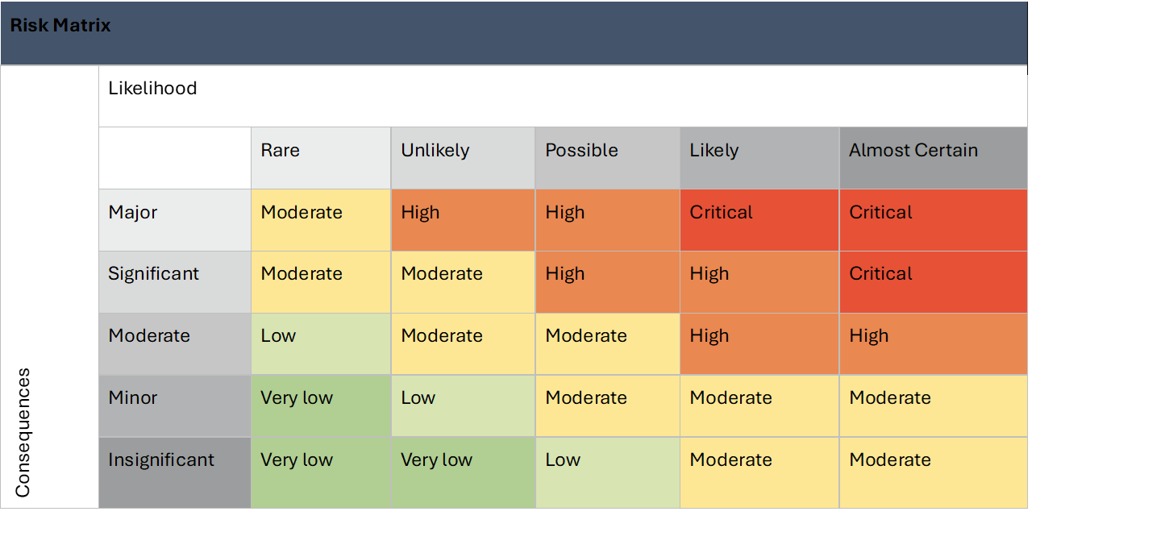

Plan and Review
Risk Assessment prepared by:  Full Name:  Signature:  Role/Position: Educator | Date:
Prepared in consultation with:  Full Name:  Signature:  Role/Position: Coordinator | Date:
Plan and review
Next Animal and Pet Risk Assessment to be conducted before: __________
*AND as soon as practicable after becoming aware of any circumstance that may affect the safety, health and wellbeing of children.

Parents & Guardians are to be consulted and provided a copy of pet risk assessment prior to children attending care. Parents are to sign this risk assessment acknowledging their child may be interacting with animals during their time at Family Day Care.

Parents Name:____________________ Childs Name/s_______________________ Signature____________________
Parents Name:____________________ Childs Name/s_______________________ Signature_____________________
Parents Name:____________________ Childs Name/s_______________________ Signature_____________________
Parents Name:____________________ Childs Name/s_______________________ Signature_____________________
Parents Name:____________________ Childs Name/s_______________________ Signature_____________________
Parents Name:____________________ Childs Name/s_______________________ Signature_____________________
Parents Name:____________________ Childs Name/s_______________________ Signature_____________________
Parents Name:____________________ Childs Name/s_______________________ Signature_____________________
Parents Name:____________________ Childs Name/s_______________________ Signature_____________________
Parents Name:____________________ Childs Name/s_______________________ Signature_____________________

